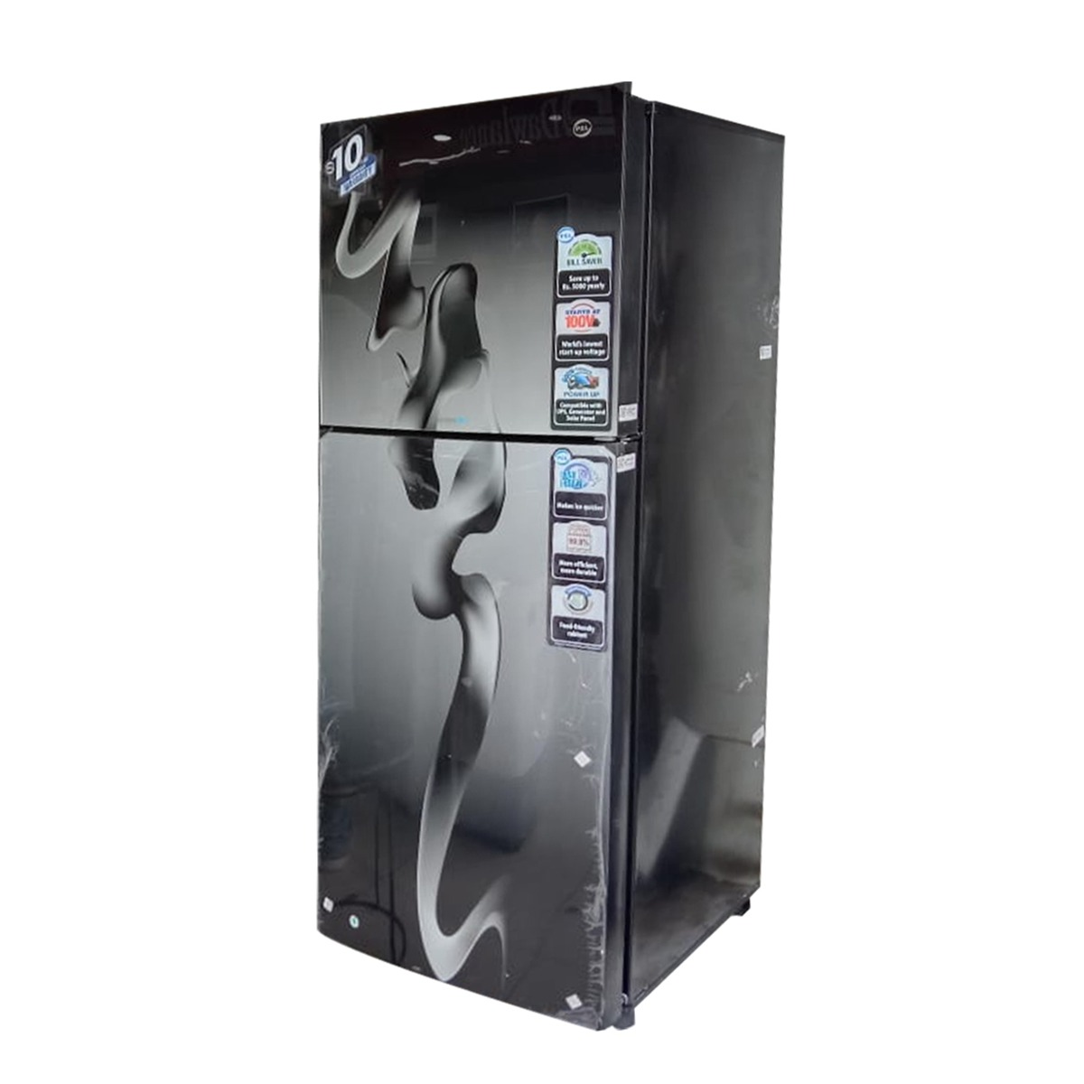

***Pel 9160LF Chrome Pro Hairline Double Door Refrigerator***

* **Color:**Silver
* **Available:**Out of Stock
* **Dimension:**131*95*300
* **Compressor:**Inverter

**Old Price:**~~Rs 302,999.00~~

**New Price:**Rs 201,999.00